Commercial TnH+IAQ Sensor with Modbus TCP/WIFI-MQTT Communication – Datasheet
1. Product Overview
WIN-SN-TnH-IAQ is a versatile data acquisition device designed for real-time monitoring in industrial applications. Providing flexibility for various measurements. The device integrates seamlessly with Modbus TCP, offering reliable communication and long-range data transfer over several meters, making it ideal for large-scale installations.
Its robust design makes it suitable for installations in HVAC systems, environmental monitoring, and process control. With configurable data sampling rates, multi-sensor compatibility, and easy configuration, WIN-SN-TnH-IAQ ensures accurate Air-quality, Temperature and Humidity data acquisition and reliable performance in demanding industrial environments, making it an excellent choice for industrial and IOT applications. Additionally, it features a 4-digit 7-segment display that provides real-time measurement data, allowing users to monitor sensor readings directly without requiring an external interface.
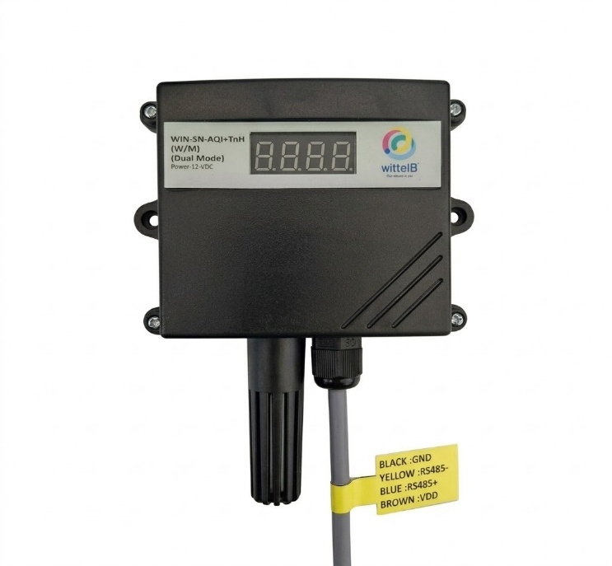
Ex: - Product Image
2. Technical Parameters
- Measuring Parameters of Air Quality, Temperature, and Humidity.
- Response Time: Less than 2 seconds
- Modbus TCP communication

 | Sensor Name | Temperature Measuring Range | Humidity Measuring range | AQI/ GAS/  Pressure | Measuring  Accuracy
☐ | BME280 | -40 ~ 85°C | 0~100% RH. | 300 - 1100 hPa | 1.0°C, 3.0 %RH,  1.0 %hPa
☐ | BME680 | -40 ~ 85°C | 0~100% RH. | 300 - 1100 hPa  & 0 – 500 IAQ | 1.0°C, 3.0 %RH,  0.6 %hPa, 15 %IAQ
☐ | BME688 | -40 ~ 85°C | 0~100% RH. | 300 - 1100 hPa  & 0 – 500 IAQ | 0.5°C, 3.0 %RH,  0.6 %hPa, 15 %IAQ
☐ | BME690 | -40 ~ 85°C | 0~100% RH. | 300 - 1100 hPa  & 0 – 500 IAQ | 0.5°C, 3.0 %RH,  0.5 %hPa., 15 %IAQ

 | Product Configuration
☐ | TnH+IAQ+E
☐ | TnH+IAQ+E+D
☐ | TnH+IAQ+MTCP+WiFi
☐ | TnH+IAQ+MTCP+WiFi+D

3. Sensor Specifications
- Wide temperature range: −40 °C to +125 °C
- Full humidity range: 0 % to 100 % RH
- Power supply DC: 12-24V@1A.
- Product dimension: 85*85*36 mm.

- Certifications:

4. Power Supply Connection
DC Connection
- Use 12-24V@ 1A, Power supply.
- Don’t make loose connection.

Recommended Cable Electrical Characteristics
22 AWG Cable Shielded and twisted pair should be used.
Tinned Copper Recommended
Nominal Conductor DCR 14.7 ohm / 1000 ft
Nominal Capacitance 11 pf / feet (conductor to conductor)
High Frequency Non-Insertion Loss 0.5db / 100ft

5. Step-by-Step Configuration
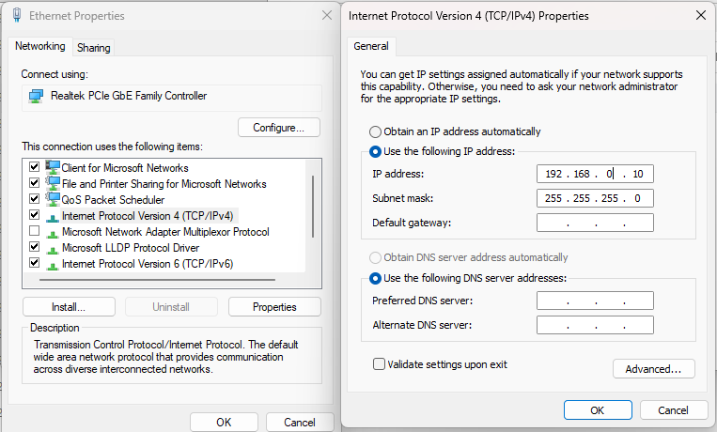
- Connect the Device

Image: 1
- Connect 12-24 VDC-1A DC adaptor to power the board
- Make the IPV4 configuration as 192.168.0.xx
- Enter 192.168.0.160 in web interface

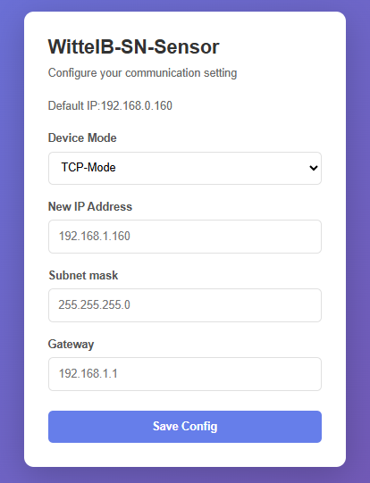
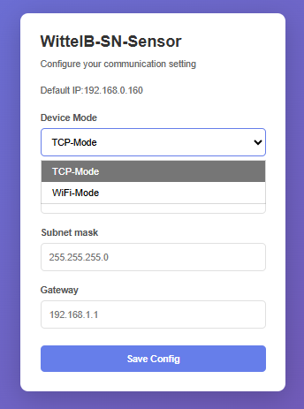
- Mode Selection

  - Enter 192.168.0.160 in the browser search bar and select the Device Mode.
  - Select the device mode as TCP-Mode to get the sensor data via Modbus TCP, or select WiFi Mode to get the sensor data in the MQTT cloud through the local WiFi network.
TCP Mode
- Here is an example of receiving data on Mb poll software.
- Open Mb-poll software connect using configuration setting (Default IP 192.168.0.160).
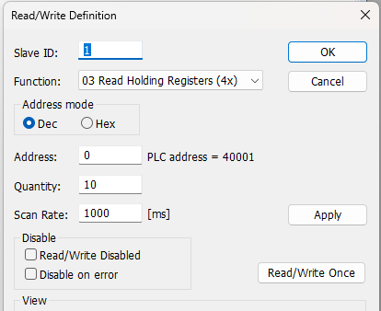
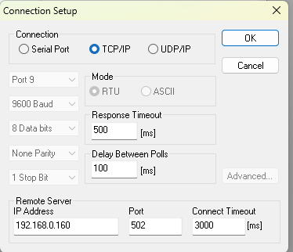
- After connecting you will get data as shown below.

- Above image shows sensor data over Modbus TCP with default Modbus settings.
- Register 40001 contains the measured gas concentration value corresponding to the connected sensor (CO/CO₂/NH₃/PH₃/H₂S/CH₄).
- Keep the jumper in the single/open as shown in image 1.2 position to change the IP address.
- Enter the desired IP address on the web page and click Save. The new IP address will be applied automatically.
- Connect using the new IP address to access the device and receive the data.
Modbus Registers Mapping
ID | Function  Description | Register  Description | Modbus Function Code | Protocol | Data Type
1 | A5S Values | 40001 | 0x03 | TCP/IP | 16-bit int
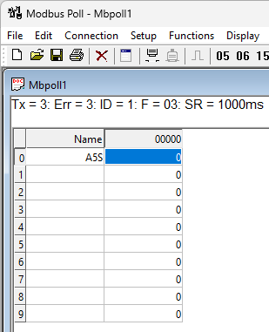

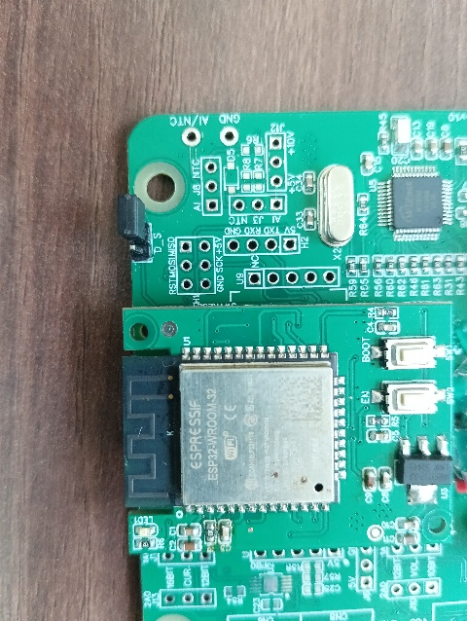
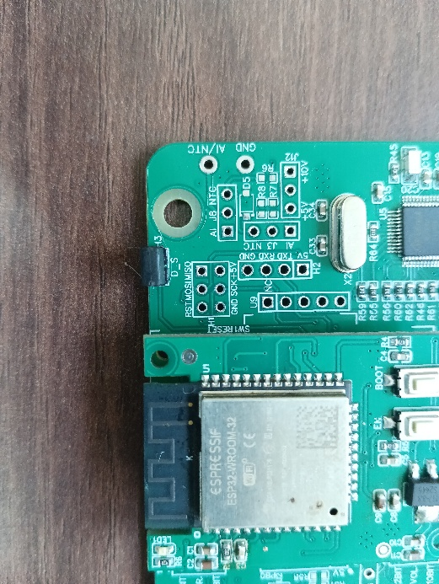

IP config JUMPER
RESET JUMPER
Image: 1.1 Image: 1.2
Hard reset Setting
- Somehow you forgot the baud rate or slave id of the board then Place the jumper (as shown in the above image 1.1) from the board reboot the system or press the reset button (given on the board). Then you will get the default baud rate of 9600 and slave id 1.

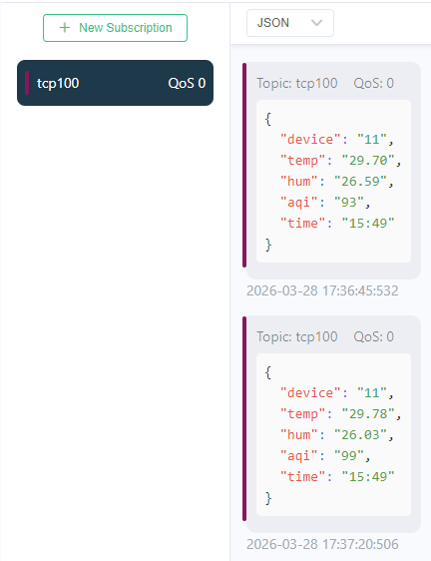
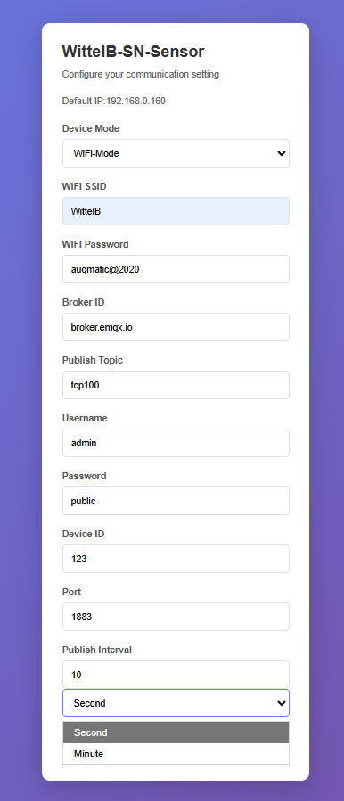
WIFI Mode:
Image: 2 Image: 3
- Enter the local WiFi credentials as shown in above image2 so the device can connect to that WiFi network. Using this connection, it will send the sensor data to the cloud.
- Then enter the required MQTT Credentials and make sure the credentials should be correct.
- As shown in Image 2, you can select the publish interval in either minutes or seconds. MQTT data will be published according to the selected interval.
- Enter the MQTT credentials to transmit the sensor data to the cloud.
- Image 3 shows the sensor data at cloud for the selected topic.
- The published JSON payload includes a real-time timestamp, allowing each sensor reading to be tracked with its exact time.

Contact Information
Augmatic Technologies Pvt. Ltd.,
Plot no 6, Shah Industrial Estate II,
Kotambi,
Vadodara – 391510.
Email – Sales@wittelb.com
Support: support@wittelb.raiseaticket.com / +91 94038 92805

